August 2014


SPRING PROGRAMME
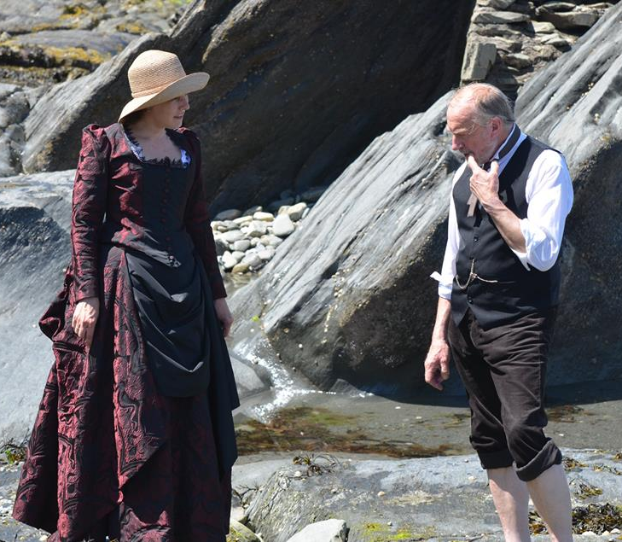
We welcomed experts on Fish – Doug Herdson, Lundy Ecology - Robert Irving, & members Sarah Hotchkiss on seaweeds & Chris Mandry -Scallops. Four sessions featured data collection. Pip Jollands & Fiona Crouch, reinforcing the importance of our contribution to the MBA’s Shore Thing survey. DWT interns shared their plans for a new Exmoor Coast protocol. Tim Jones promoted the Wetland Bird Survey so well that several members have since joined the survey team.
Everyone got to work on Elaine Hayes’ seascape wordle & during our own marine animal quiz & seashell challenge. Later the Roberts’ photo competition was inaugurated with dozens of entries, won by Sue Austin & Kevin Faulkner with two classic beach scenes.
NEW FOR AUTUMN
Programme starts
9 October
Visiting speakers include:
23 October Martin Dory, all things coastal
30 October Emily Penn adventurer & oceans advocate
6 November Marine Biologist Keith Hiscock

SCIENCE AT THE SEASIDE
We were delighted when approached by Ilfracombe Museum for advice on their Science at the Seaside project funded by FLAG (Fisheries Local Action Group). We got a chance to recommend several speakers, many of whom had contributed to our past programmes. Jim Monroe launched the series of 10 talks with an introduction to Gosse and other Victorian marine naturalists, & Sarah Hotchkiss brought the series to an end with a historical approach to interest in seaweed and a memorable finale, a seaweed hand-wash. Other events included workshops and rockpool rambles, some still to come.

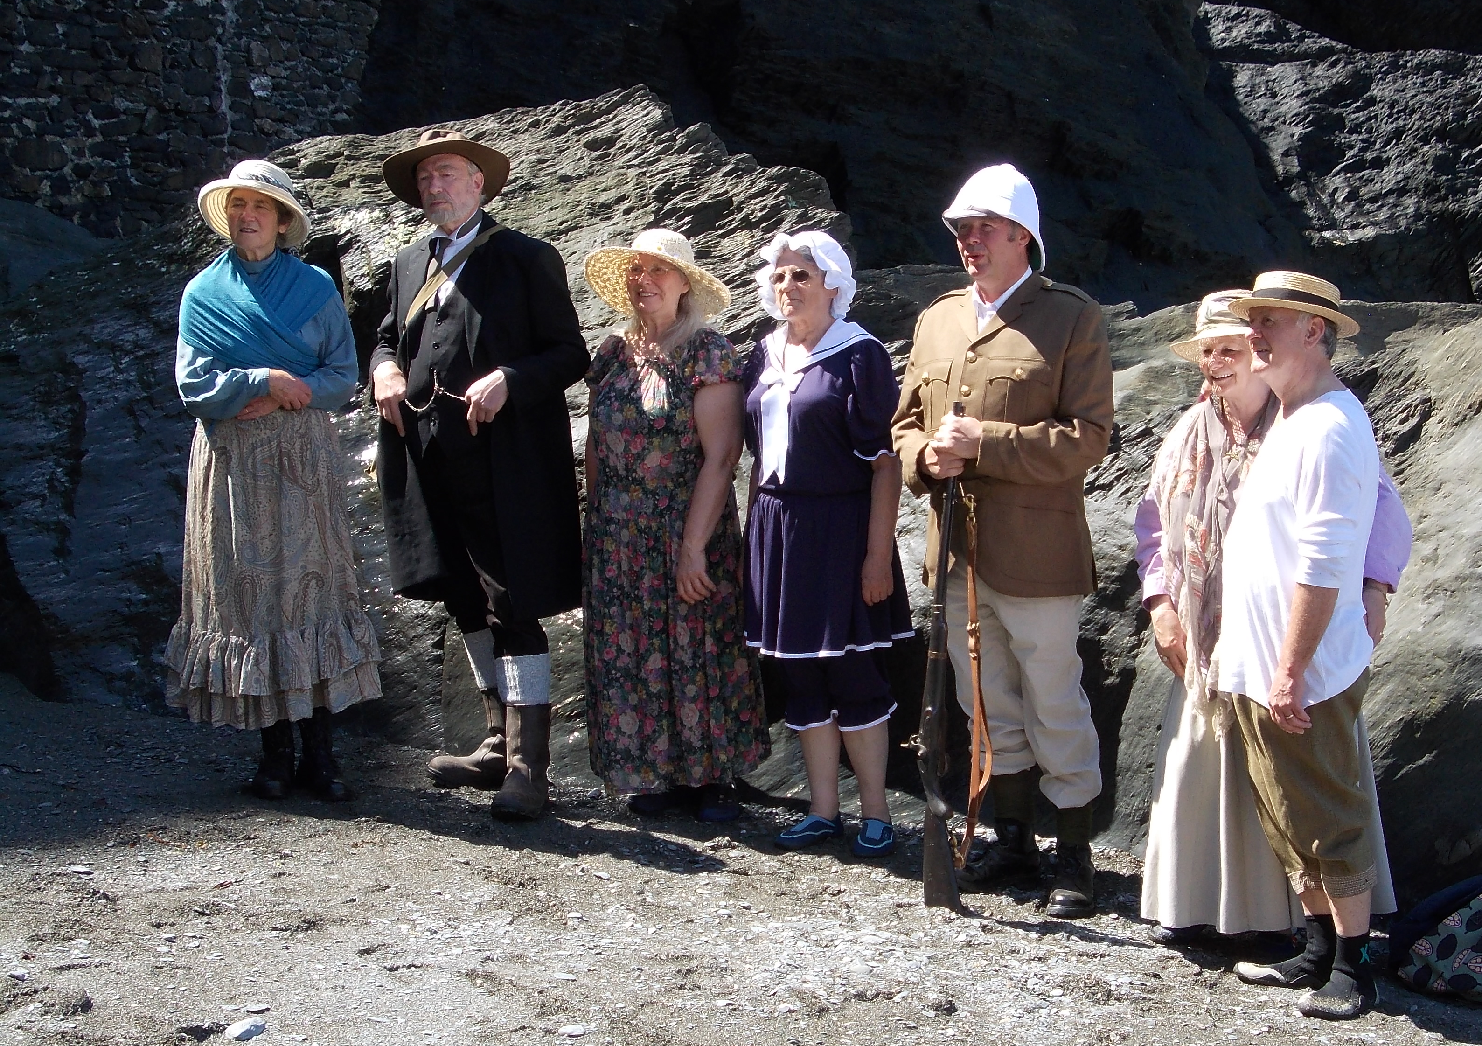
These are photos from the Victorian Week ramble at Tunnels Beach led by Jim Monroe and keenly supported by Coastwise members, who enthusiastically joined him in costume. Alison Mills, North Devon Museum’s curator, struck a fine pose alongside Jim, but not for her clambering about the rocky shore. Though this proved relatively easy for the men, the women had to get their skirts out of the way, unless like Sandy Johnson (fourth from left) they had made the perfect outfit, complete with bloomers. Tucking up her skirts, Janice Whittington made the find of the day, tiny nudibranchs, Polycera quadrilineata, dotted across the Serrated Wrack. The whole escapade made the achievements of the Victorian women marine naturalists seem all the more remarkable.

SPRING VISIT

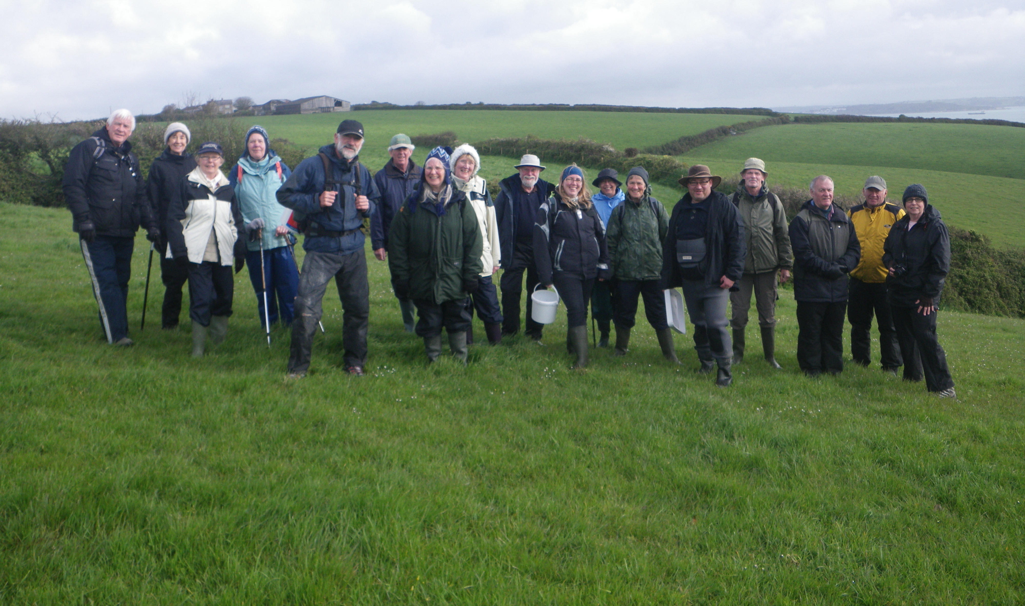

Mavis Symons organised another very successful spring break for members. She says “Twenty members visited the Falmouth area for two seashore safaris on 26 & 27 April under the skilled guidance of Trudy Russell, a marine advisor with Natural England, and her husband Jason Birt, of Newquay College. The highlight, amongst many other delights, was the visit to Prisk Cove,and a wonderful few hours followed with finds including the Shore Clingfish (Lepadogaster lepadogaster), Green Shore Urchins (Psammechinus miliaris), a very unusual Red-speckled Sea Anemone (Anthopleura ballii)- above, and some beautiful nudibranchs.”
FLOTSAM
Sand-life Buckets and spades were the order of the day at a workshop held at Westward Ho! on 16 May. The MBA’s Jack Sewell led with a presentation about animals living in sand, in the spanking new Westward Ho Baptist Church Hall, before taking us to the beach, 5 minutes’ walk away. The main focus was on the larger animals, those that can more readily be seen, or leave traces on the sand, razor shells, urchins, necklace shells, sand hoppers with their myriad smaller look-alikes and a huge variety of worms. Paula Ferris said “Sorting out our cats from rags was about as far as any of us got, but it was a beginning and a first for Coastwise as we have confined our attention to the rocky shore until now”.
Shore Thing Members were determined that our shore monitoring at Lee, always popular, and Abbotsham, ;less so due to its boulders should continue. Both were surveyed in July – a thoroughly enjoyable experience.

Shelly beach, Barricane, lived up to its name when Bas Payne of the Conchology Society, shared his finds with coastwise members in July. It was a privilege for members to watch an expert observer at work. His tally, 37 species, though roughly in line with past surveys, was far in excess of Coastwise finds, and included two that were new for the10 km sq NBN record.
Dormice Janice Whittington & Colin Jacobs joined forces to in June check out the Bucks Mills Dormouse boxes post hibernation and were rewarded with a dormouse in the first box.
Two microscope workshops were held during the spring. The first in Mortehoe Village Hall focussed on seaweed animals for which the Biosphere Foundation’s Field Scopes proved to be excellent. The second, held courtesy of Ilfracombe Dive Club at their lovely clubhouse, targeted plankton. Jim Monroe & Robert Down braved a thorough drenching to trawl successfully for plankton from the harbour and their haul delighted over 20 members who got excellent views on the laptop via Rotary donated camera& microscope.
The South-West Marine Ecosystems conference held in April at Plymouth Marine Labs attracted nearly 200 marine enthusiasts including Janice Whittington, Dave Jenkins & Paula Ferris from Coastwise. Research updates were delivered by the region’s researchers and students on marine topics ranging from plankton to sea mammals, storms and sea conditions in a programme whose networking potential was amply fulfilled as planned by organiser Robert Earll.
Photos Coastwise now has a waterproof camera for beach use which is held by Sue Austin.
Everyone is also encouraged to take their own photos which they can now upload direct onto the website by registering with Web Master Robert Down. Use is also made of the Coastwise Facebook page administered by Janice Whittington. The various specialist Facebook groups are helpful in identifying species.
Recording citizen science data is a concern not only to Coastwise but to regional & national agencies. Individually members use irecord and ispot but avoid the complications of Marine Recorder, better suited to the professionals. As a group we are conducting walk-over surveys this summer and Sue Austin is holding the results on computer pending the emergence of a national consensus on best practice.

Edited by Paula Ferris, January 2014
www.coastwisenorthdevon.org.uk

