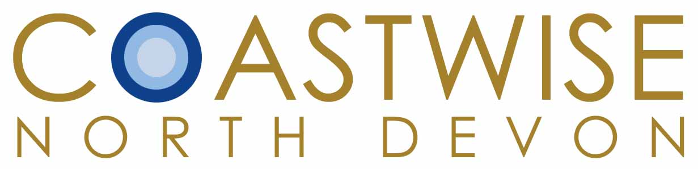

Report from the Co-Chairs, December 2010

This has been a busy and important year for Coastwise, particularly for its conservation objectives and educational outreach which have provided opportunities to work in close partnership with key organizations in the interests of North Devon’s marine environment. We have summarised our activities below, and this year has again shown that members get the most out of Coastwise by participating in those activities in which they have a particular interest.

Marine Conservation Zones & the Biosphere Partnership
The Marine & Coastal Access Act 2009 sets out to create a planning environment to care for the sea, no easy task, but vital. Under the Act a network of Marine Conservation Zones is to be created around the country, not all no-take zones, but each with appropriate levels of protection. Finding Sanctuary is the southwest agency responsible for submitting MCZ proposals to Government by next summer with input from the Devon MCZ Group on which Coastwise is represented. After the first meeting Jill Portsmouth alerted us to the low response to initial consultations from North Devon, so, with encouragement from Coastwise, the Biosphere Reserve set up a Marine Working Group to coordinate representative local input, chaired by Robert Down.

Several other Coastwise members also have an active role: Paula Ferris, Jill Portsmouth and Malcolm Roberts, Coastwise representative on the Estuary Forum. The MWG’s aim is to identify and then safeguard the most precious North Devon marine environments by proposing levels of protection for them, on which consensus sought. Good progress is being made. Submissions to the Devon MCZ Group by the MWG have been well-received so far, and focus on the estuary, the VMCA, and areas of the seabed to the west & north west of Hartland Point and to the west of Morte, recognised for its exceptional animal communities. Much work remains to be done on sourcing the supporting data and detailing levels of protection.

Key organisations have provided support and expertise including Natural England, the Inshore Fisheries & Conservation Agency, and Finding Sanctuary.

Shore Safaris.
Having successfully completed their AONB funded training programme, the Coastwise Shore Safari team began their season by supporting the AONB/ Combe Martin Seashore Discovery Day. The rockpool rambles held in the afternoon were well supported by an enthusiastic public. Coastwise hosted a further seven events at Barricane, Lee Bay and Combe Martin and supported the National Trust in its new venture of “Rockpool Safaris” at Barricane in a further eight events. The 12th. August saw a joint effort, with Coastwise and the Trust pooling resources and advertising for a very successful day of collaboration. The season ended with the Shore Safari team supporting “Sea Ilfracombe” on 11th. September.

Shore Research - During the Spring twelve Coastwise members surveyed, sampled and recorded on our shores and estuaries. Braving winter weather they took part in projects supported by Ambios Ltd, funded by the Government’s “Learning Revolution” initiative, for innovative and informal adult learning projects.
1. An Anemone Study to survey movement, growth etc. by our anemone species in the winter months.
2.A Plankton Survey to collect and identify inshore samples in the months before Spring growth.
3. An Invertebrate Study. What lives in the muds of the Taw/Torridge Estuaries? What eats what in the relationship with over-wintering wading birds?
Jim Monroe “All three projects contributed greatly to our knowledge, they enthused us, and helped us to develop some simple surveying techniques and buy some basic kit. Most importantly they left us keen to explore further ways Coastwise members can generate interest in shore life and contribute to knowledge.”

Our Coast Course Programmes
Through the talks programmes Coastwise was able to call upon experts to help us understand the Marine Act, its stakeholder approach, and the requirement for data to underpin the scientific basis for MCZ selection: Prof. Peter Howard - Whose coast?, Natural England’s Andrew Knights - introduction to the Act, consultants Doug Herdson and Dr Phil Smith, respectively, on monitoring climate change impacts, and managing the marine environment, a biologist's perspective, and Jenny Salmon’s on Devon Wildlife Trust’s marine survey work, sadly now discontinued,. The programme also ensured that members never lost sight of the objectives of marine policy, the wildlife and its habitats: Tegwyn Harris (worms and mud), Tim Jones (estuary birds), Pip Jollands (shore life), Chris Mandry (diver’s depths), Chris Cornford (Bideford Bay), Maranda Coleman-Cooke (Braunton Marsh) and to top it off Paul Madgett (clouds).

Visits & excursions
Coastwise now offers a year-round programme with a very full summer schedule of events on the shore, and plenty of occasional trips and activities initiated by members, several of which are becoming regular fixtures: our annual 3 Shore Thing beach monitoring sessions with Pip Jollands, the Christmas Lunch, the spring beach clean at Downend, John Broomhead and Rob Jutsum’s birding trips locally to Isley and, further afield, to the Exe Estuary. John is trialing social get-togethers to develop ideas and friendships otherwise constrained by the limited time at our Library meetings. Paul Madgett took us to Hartland, Jay Nicholson organised a visit to SAFHOS, the plankton people, and several of us have enthusiastically accepted invitations from MBA/Marlin to learn more by participating in their events. In addition to our annual beach profile reviews, members have got together to survey shores at Greencliff, Westward Ho! and Lundy, where an encounter with a Common Eel provided an addition to Lundy’s list.

Robert Down
Paula Ferris
Co- Chairs

Statistics

Attendance/Membership

Our Coast 2006/7
Autumn & Spring
Full members 35
Associate 12

Autumn & Spring 07/08
Full 35
Associate 12

Autumn 08/09
Full 48
Associate 14

Spring 08/09
Full 35
Associate 35

Autumn 09/10
Full 49
Associate 14

Spring 09/10
Full 44
Associate 16

Autumn 10/11
Full 48*
Associate 20
* including 2 free places

The next, 10th, session starts 13th January

Library capacity, 54, limits attendance, modest recruitment via word of mouth, press publicity and the September display of Rob Jutsum’s photographs in the Library continues to deliver a full complement.

Background
Coastwise North Devon was set up in 2008. The group developed from the Our Coast course, now in its fourth year. The aim of Coastwise is to champion the North Devon marine and coastal environment by:-
a. promoting knowledge, understanding and enjoyment of the natural and cultural history of North Devon’s coastal and marine environments
b. undertaking associated educational, research and other relevant activities
c. working with other organisations to achieve the above.

Committee meetings are held quarterly.
Policy discussion at the latter has identified priorities as follows:
1. Learning about the marine and coastal area
2. Undertaking associated “interest” projects such as Beach Surveys and Oral History
3. Representing, influencing, in areas such as such as the ND Biosphere, local and national politics

